Our Teachers
One of the secrets for success in any educational setting is caring, committed teachers, and Johnson County Montessori Preschool has some of the best! Our teachers have literally decades of experience and several have been teaching at our school for many years – that’s quite an accomplishment in a field where high staff turnover can be all too common.

Johnson County Montessori Preschool is an approved Montessori Educational Programs International (MEPI) internship site, which is important for training the next generation of highly qualified early childhood educators in the Montessori tradition.

Barbara Lyons, Director
Barbara Lyons joined our staff as director in 2000. She has a degree in Human Development and Family Life with an emphasis in early childhood education from the University of Kansas. Since receiving her degree in 1973, Barbara has been active in the early childhood education field as a preschool/Head Start teacher, Child Development Associate (CDA) program specialist, Head Start program evaluator, YWCA division director, and Montessori school director.

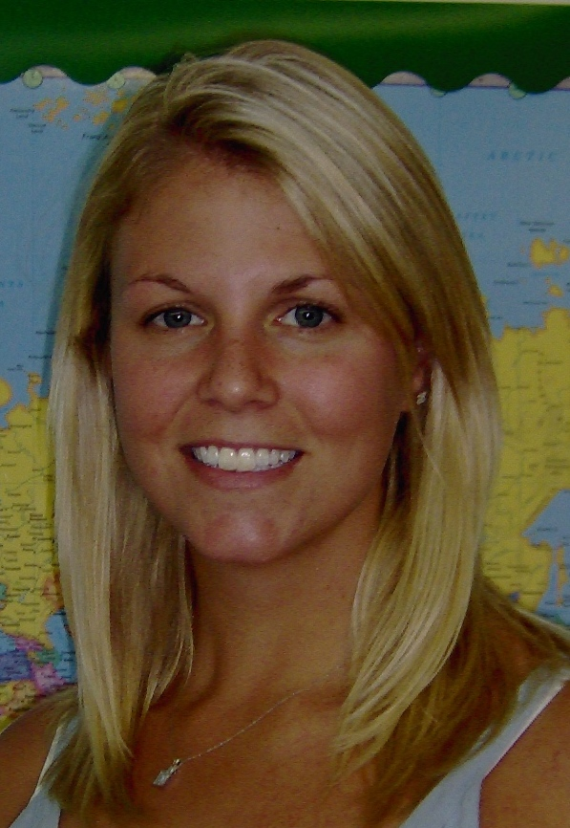Cassie
Cassie began her career in early childhood education at our school in 2000 when she was still in high school. Cassie started out as a part-time afternoon aide and worked with us as a teacher assistant until 2003, when she decided to earn her Montessori early childhood education certification at Lavonna Peterson’s Early Childhood School. Cassie then rejoined our staff as a fully certified Montessori teacher in 2005.

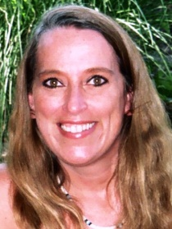
Tammy
Tammy earned an applied science degree with an early childhood emphasis in 1987 and is qualified as a Director in the state of Kansas. She received her Montessori certification in 1997 and has been teaching at our school since 2002. She has more than 21 years of experience in the early childhood field as a program director, Montessori teacher and an infant/toddler teacher. Tammy worked at Cernerkids for seven years prior to joining our staff.

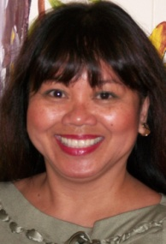
Emilie
Emilie’s 25-plus years of experience working with children includes 16 years at the Saint Agnes Montessori School, where she worked as an assistant teacher, director, and field trip coordinator. She has a chauffeur-level driver’s license and is also qualified as a Director in the state of Kansas. Emilie began teaching at our preschool in 2003 and obtained her Montessori certification through Montessori Teacher Preparation of KC.
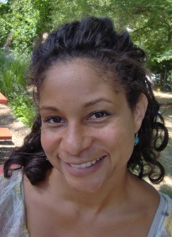
DeJarne (Deja)
Deja started working at our school as a teacher in January 2009. Prior to joining our staff, Deja had a decade of experience at other Montessori schools, including six years at Casa De Los Niños as a kindergarten and pre-K teacher and Before- School Care Coordinator. Deja originally fell in love with the Montessori approach when she was the nanny for a child who attended a Montessori school, and decided to take Montessori training through the NCME program.

Anna
Ms. Anna started joined our staff as a substitute teacher in June 2012 and has been a steady presence ever since. Anna is a U.S. citizen who was born in Brazil. Anna taught preschool in Brazil and is also a registered nurse.

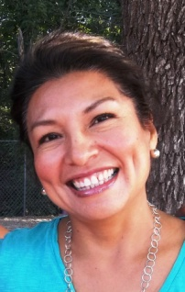

Nancy
Nancy received her Montessori teaching certification in Peru in 1998 after earning a Bachelor’s degree in psychology in 1994. She came to the United States in 2003 with a plan to work at Christots Montessori for three years and then return to Peru, but then she met her husband, had a daughter and is now a proud citizen of Shawnee, Kansas.

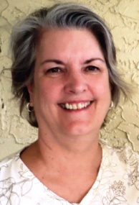
Ann
Ann has taught Suzuki music lessons at our school since 2001. She integrates the Montessori and Suzuki philosophies in group and individual lessons on Tuesday and Wednesday mornings during the regular school year. Ann has many years of experience as a self-employed Suzuki piano teacher and several of our children continue private lessons with her. Anne’s Montessori knowledge has its roots with her own five children, who attended Montessori schools.

Angie
Angie has worked with us for more than five years and does a wonderful job of preparing healthy meals and snacks for the children on a daily basis. She is very creative at incorporating nutritious fruits and vegetables in a child-friendly way. Angie not only cooks, she also works in the classrooms in the afternoons and early evenings and substitutes as needed. One of Angie’s daughters also attended preschool here.

Substitute Teachers
Our corps of substitutes includes teachers with a combined 60 years of experience working with children in a Montessori environment.

