

#### Johnson County Montessori Preschool

**Parent Publication**

Back to School 2016 www.jocomontessori.org

**Starting the School Year Smoothly**

Here are some simple morning practices to follow to help us make the school day go smoothly for everyone:

* To set your children up for success and learning, please arrive with them well rested and tummies full with a healthy breakfast if you arrive after 7:45 am.
* To help everyone ease in to the school year, we start our days on the play-ground (weather permitting) and are in the classrooms for Montessori line time or work time by about 8:30 or 9 a.m. As the children grow more comfortable with our school environment and develop progressively longer attention spans, we’ll go indoors earlier. It won’t be long until we are starting the cool mornings in the lunchroom (for those who arrive between 7 & 8 a.m.) or in the classrooms, with children going directly to work with Montessori materials and other learning tools.
* Children should wear comfortable play clothes that can withstand the rigors of outdoor play in the pea gravel and sand boxes, and messy art projects. You’re likely to encounter some happily dirty kiddos at the end of the day.
* Child should wear sturdy athletic-style shoes to school. Our pea gravel play-ground surface gets dusty and can be rough on shoes and tender little feet, so avoid sandals, flip-flops, Crocs®-type clogs with open heels or sides, or slick-soled dressy shoes.
* Each child also needs to have a *complete* change of clothing appropriate for the current season to keep at school for the inevitable accident or spill. Please label every single item with your child’s name! As the morning temperatures grow cooler, be prepared to start sending a jacket or sweater each morning (or feel free to keep an extra one here at school).
* At the start of each week, each child needs to bring their own sleep sack or sleeping bag for their naptime cot. A cuddly toy is optional. Take your child’s bedding home for laundering at the end of the week and bring it back to school at the start of the next week.
* ALWAYS sign in and out on the sign-in / sign-out sheet for your child’s classroom.
* Say good-bye to your child, grab a quick hug, and head to work – we’ll handle it from there! Feel free, of course, to call to check in on your child during the day (naptime is a good time to call).

Our teachers also have guidelines for their respective classrooms, which they share with you during classroom-specific back-to-school nights, the all-school open house, in our monthly parent publications, and via their own communiqués.

MCED00296_0000[1]We hope you will take a little time each morning to meet and get to know all of our teachers and staff, as well as other parents and children. We’re a close-knit group, and your involvement in our school makes us even better!

## *Reminders*

* Help us teach the children that ADULTS should be the only ones opening the gates that lead to our fenced play-ground. Please encourage your child to wait at the gate until you or another adult opens and closes it.
* We also hope to see children staying right next to the adults who escort them to and from our parking areas. Please encourage walking and discourage running in these areas.
* If you are concerned about protecting your child’s skin from sun damage and insect bites during these warm days of late summer and early autumn, please apply sunscreen and insect repellent before you leave your house for school. We can apply sunscreen and bug stuff later in the day if we have your written authorization.
* Our school closes at 6:00 in the evening. The late pick-up fee is $1.00 per minute, payable in cash that evening to the teacher who is on duty.

**Driveway Do’s and Don’ts**

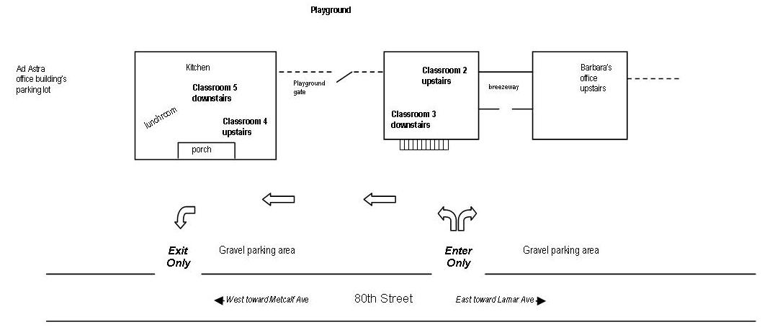Help keep traffic flowing smoothly and safely by entering and exiting our driveways as follows:

***For safety’s sake, NEVER leave your car engine running in our driveway or parking areas.*** If you’re going to be away from your car for more than 2-3 minutes, **pull into a space in the gravel parking area or park along the south side of 80th Street.** This way you won’t trap another parent’s car in our driveway and possibly make them late for work.

**Dates to Note for September and October**

September 9 Grandparent’s Day celebration, 8-10 a.m. on the playground

September 14 All-school open house (children are especially encouraged to attend this event)

October 3 Chief Eagle Bear visits

October 7 Field trip to area pumpkin patch

October 31 Halloween trick-or-treating

**You’re Invited to Annual All-School Open House**

Our annual **All-School Open House**, which parents *and* children are encouraged to attend, will be Wednesday, September 14, starting at 5:30 p.m. Your children will have an opportunity to demonstrate their Montessori skills and you will have a chance to become more familiar with your child’s classroom and meet classmates and their parents.

 Please be our “friend” and visit us on Facebook! Traci Johnson (mother of Liam and Harper) has been managing our school’s Facebook page and does a fabulous job at keeping it current with information on activities, the lunch menu, photos, etc. Traci also answers questions that are posted on our page.

Feel free to post photos or information to our page yourself, or send your items or links to Traci at [tljohnson32@gmail.com](mailto:tljohnson32@gmail.com) and she’ll get it done. Also, be sure to “like” a post on occasion to continue see us in your Facebook news feed.

**School Closure Dates for 2016-2017**

Mark your calendars now and make alternative child-care arrangements as necessary for the following dates that we will be closed:

September 5, 2016 (Labor Day holiday) May 29, 2017 (Memorial Day holiday)

November 24 & 25, 2016 (Thanksgiving holiday) May 30 & 31, 2017 (preparation days for summer session)

December 26 – 30, 2016 (Christmas / New Year break) July 3 & 4, 2017 (Independence Day holiday)

We are tentatively scheduled to be closed August 7-11, 2017 for our 2017-’18 school year preparation week; dates to be finalized later this year.

**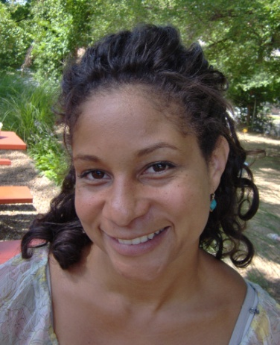Who’s Who at Our School**

**Classroom 2 – Ms. Deja and Ms. Susan**

Deja continues as lead teacher and will celebrate her eighth year of gentle teaching at our school this year. Deja was introduced to Montessori when she was a nanny for children who attended a Montessori school. She was so impressed, she enrolled her own daughter, Lexie (now 17) in a Montessori school and attended the NCME teacher training facility in 1999.

Susan Moreland, sister of our beloved Ms. Anna, has been working with us since December 2015, most recently on a full-time basis in room 3 this past summer. Susan has lots of experience working with children as part of her parents’ missionary work in Brazil. When Deja leaves at 3:00 each afternoon, Susan will be joined by Mary (in her fourth year with us) or Tehya (in her second year) until the end of the day. Mary is known for her creative and very entertaining storytelling with lots of child participation and her love of the outdoors. Mary will brave any heat or cold to give the children every opportunity to play outside. Tehya had experience babysitting three boys and was referred to us by the early childhood education teacher at her school.

*Deja Cross Susan Moreland*

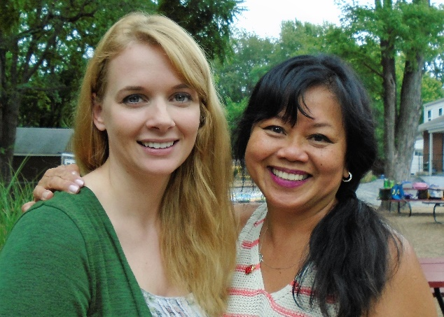**Classroom 3 - Ms. Emilie and Ms. Juliana**

Emilie is celebrating her 13-year anniversary with us this month. Emilie’s 25-plus years of experience working with children includes 16 years at the Saint Agnes AMI school, where she worked as an assistant teacher, director, and field trip coordinator. She obtained her Montessori certification through Montessori Teacher Preparation of Kansas City and is qualified as a director in Kansas.

Joining Emilie is Juliana Fisher, who is new to our school. Juliana received her bachelor’s degree in early childhood education from Park University in 2014. She has worked as a preschool teacher for the past five years, most recently at Brookridge Day School. Juliana is very interested in learning more about the Montessori method. In September, Karen Cook, who has been with us since October 2013, will work a couple of afternoons with Juliana. Karen is in the process of earning her Montessori certification and has been interning with Emilie.

*Juliana Fisher and Emilie Hudson*

**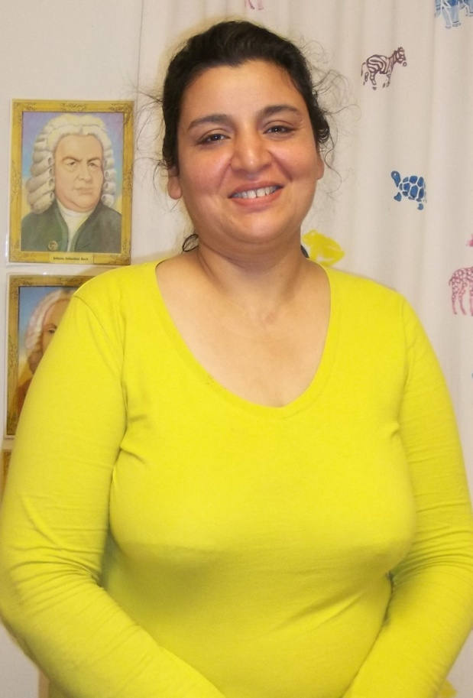Classroom 4 - Ms. Tammy and Ms. Lubna**

*Tammy Lamar Lubna Nasim*

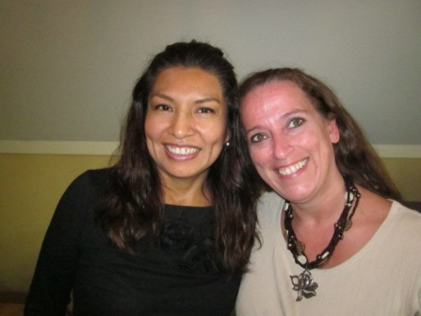

Tammy has a degree in early childhood education from Illinois Central Community College and has been teaching preschool since 1987. Tammy obtained her Montessori certification through Montessori Teacher Preparation of Kansas City and also qualifies as a Director in Kansas. She started with us in 2002 and has been the first face most children see in the mornings at our school for 15 years.

When Tammy leaves at 2:00 each afternoon, Lubna takes over in room 4. Lubna had been working with us since February 2013 and has been a steady presence in room 4, as well as our ‘go to’ substitute in other rooms. Lubna started her child-care career with us after volunteering with Head Start. She also taught grades 1-9 for 10 years in Pakistan. Since her husband passed away in the past year after an extended illness, she has been raising her two wonderful children on her own. Lubna is a valued and steady presence at closing time every day.

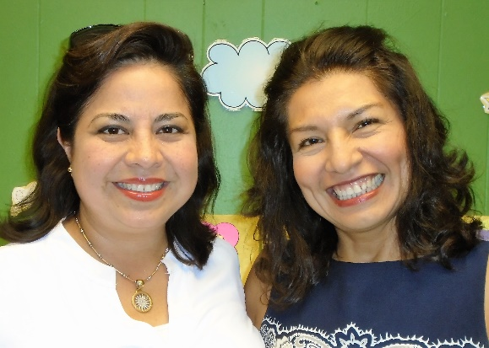**Classroom 5 – Ms. Nancy and Ms. Veronica**

Nancy came to the United States from Peru in 2003 to work as a Montessori teacher at Christots Montessori School. She met her husband, had her daughter, Gracia, and has been in the States ever since. She joined us in August 2012 as an afternoon assistant, and for the past few years has been managing her own classroom. Nancy earned a degree in psychology in 1994 and her Montessori certification in 1998 in Peru.

Veronica started working with us in May 2015. She is multi-talented, with a degree in international business and a fine eye for and experience in interior design. Veronica put together the space for our non-nappers this past *(continued)*

*Veronica Peralta Portuguez and Nancy O’Brien*

**Who’s Who in Classroom 5 – continued**

summer and they had a wonderful, peaceful time in the area she designed. Veronica also works as a Spanish teacher at Brookridge Day School. When Veronica leaves in the afternoon, Lala, Sarah, or Sandy will come in to work in room 5.

Lala Jones - her given name is Yolanda, but children have been calling her Lala for ages - has worked with us as a substitute teacher, cook, office helper, etc., since 2008, but has really found her niche as part of the room 5 team on Monday – Wednesday afternoons. She will also continue to help Barbara in the office.

Sarah Gregg started working here in 2010 and has been with us on and off as a part-time or full-time teacher and substitute cook. She has also managed to tend to her family and go through the Montessori Teacher preparation of Kansas City program during this time.

We were thrilled to welcome Sandy Monday back in September 2015. Sandy first taught here in 1990, then went on to earn her Montessori certification in 1995 and her elementary education degree in 1999.

Tasmia Nasim will join the others when Nancy leaves at 3 p.m. Tasmia is Lubna’s daughter and we have watched her grow up over the years. Tasmia started working here this past summer and has practically been a full-time presence from the start. She has a very creative side, so expect to see some special crafts in the afternoons.

**Other Staffers**

Kim Hooper attended preschool here as a young child and has always wanted to come back and work. She received a BA degree in psychology from Rockhurst University in 1995 and her Montessori certification in 2005. She helps during art class and works on language activities with small groups of children. She has also spent part of her summer preparing some new language materials for us.

Marleena McGrill taught here previously from 1986 to 1999 and obtained her Montessori certification in 1990. She ran a licensed Montessori infant/toddler program in her home when her daughter was little and also served as the director at Lavonna Peterson’s Montessori School for a few years. She is happy to be back with us in the classrooms.

Angie Karnes has been a part-time and substitute teacher, chef, and good-will ambassador for us since 2006. Her current full-time role is preparing healthy lunches and snacks for the 75-plus children we now serve. Expect her to WOW you and your children with her healthy and tasty meals. She is incredibly supportive of any special dietary requirements or restrictions and will do her best to accommodate your children’s needs.

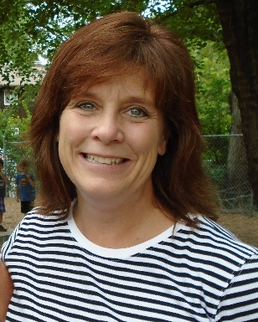****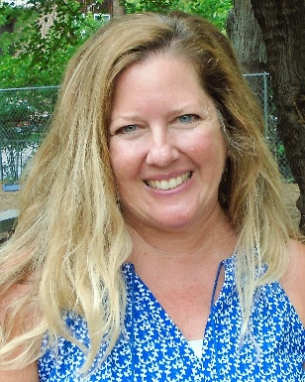**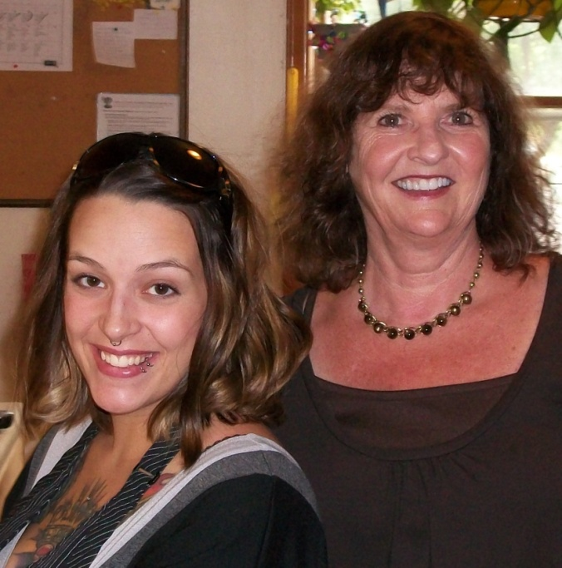**

*Angie Karnes, chef & substitute teacher (left); and Barbara Lyons, school director (right)*

*Marleena McGrill, sub (and former full-time teacher from the ‘80s & ‘90s)*

*Yolanda Jones (a.k.a. Ms. Lala), part-time teacher (room 5), sub & office aide*

*Kim Hooper, part-time art & language aide (and alumna of our school)*

*Sarah Gregg, part-time teacher (room 5) & sub*

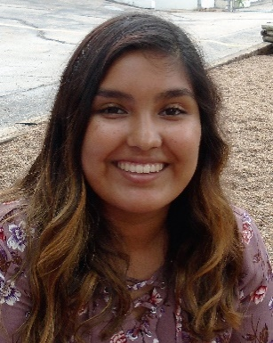******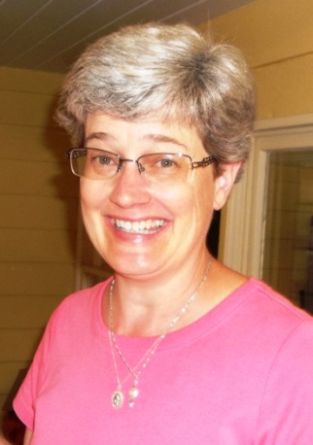**

*Not pictured: Alisha Vincent, art teacher; and Karen Cook, part-time teacher/intern (room 3)*

*Sandy Monday, part-time teacher (room 5) & sub (and former teacher from the ‘90s)*

*Alyssa Rodriguez, sub*

*Tehya Robles, part-time teacher (room 2) & sub*

*Mary O’Conner, part-time teacher (room 2) & sub*

*Tasmia Nasim, part-time teacher (room 5) & sub*

** Musical Notes from Ann Stein**

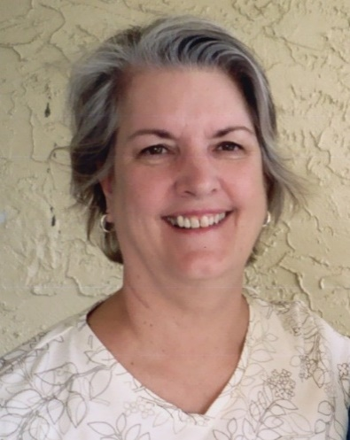

Ann Stein

For parents who are new to our school, here’s an overview of our music program. I’m a Suzuki piano teacher in the afternoons and I integrate the Montessori and Suzuki philosophies in my teaching here at school in the mornings. Put simply, every child can learn when given personal freedom in a prepared environment. Just as reading aloud to children is a vital part of teaching them to read later, providing high quality music for children to absorb is a crucial step in preparation for singing, dancing, and playing musical instruments.

I teach each class for 30 minutes on Tuesdays and Wednesdays. All the materials I introduce are placed in the classrooms. Students will have an opportunity during the week to listen to classical music and work with music materials on their classroom’s music shelf. You’ll learn more about our music program in the months ahead.

**Optional Enrichment Classes Start in September**

Our wonderful Suzuki music lessons taught by Ann Stein and art lessons with Alisha Vincent are included in our monthly tuition. We also have some optional enrichment opportunities available for additional fees.

* Ms. Deja’s **Dancin’ with Deja** ballet and creative movement classes introduce children to the basics of dance in an active, creative and fun way. Children learn elementary ballet positions, large-motor dance movements, and strengthening postures that help develop grace and confidence. Classes are held once a week on Tuesday or Thursday afternoon at a cost of $25 per month. Enrollment forms are being distributed.
* Ms. Nancy offers **Spanish lessons** that teach short phrases, colors, numbers, fruits, shapes, the alphabet, parts of the body, and much more. Her teaching techniques, including songs, videos, games, and hands-on crafts, use all five senses, just like we do with our first language. Classes meet on Friday mornings here at school for 30 minutes and cost $30 per month, *as long as there is a minimum of five students*.
* The **Happy Feet soccer program** teaches this sport, along with encouraging fitness and enhancing motor development, using stories, songs and soccer balls. All of the children who attended our school’s summer program on Fridays participated in Happy Feet classes, and they had a ball! During the school year, Happy Feet classes are held on Monday mornings for 30 minutes and cost $32 per month. Enrollment forms are being distributed.



Our school participates in ***Healthy Way to Grow***, a nationwide technical assistance program for child care centers aimed at decreasing obesity among children from birth to age five. The program provides hands-on assistance, customized training, resources, and tools to support healthy lifestyles in child care environments and is implemented by the American Heart Association and The Nemours Foundation.

A good breakfast sets the state for better learning. There is simply no disputing the fact that students who eat a healthy breakfast pay more attention, are more creative, think better, and score higher on exams. A good breakfast is also a critical step to preventing obesity. To this end, we’d like to pay greater attention to what our students are eating before their school day with us begins and do what we can to encourage healthy eating. While we don’t want to be “breakfast police”, if we should see a student scarfing down a chocolate-iced doughnut as they’re walking in with their parent, a gentle reminder from about healthier alternatives might be forthcoming.

We’ll also do our part by preparing lunches that are packed with nutritional value; stressing physical activity through daily outdoor play, soccer lessons and options like dance and creative movement; and providing a proven-effective Montessori learning environment does not include sitting in front of a computer screen.

We encourage you to take an active role in your child’s nutrition and physical activity choices, especially right before your child comes to school. As the school year progresses, look for more information about our efforts to improve learning through healthier lifestyles.