#### jcmslogo Johnson County Montessori Preschool

** Parent Publication**

January & February 2016 www.jocomontessori.org

[](https://www.google.com/imgres?imgurl=http://cdn1.theodysseyonline.com/files/2015/12/21/6358626753874824561805500835_2016.jpg&imgrefurl=http://theodysseyonline.com/toledo/lets-make-2016-ours/257525&h=382&w=917&tbnid=R2xj87yl7Bh1IM:&docid=lIixeEGUz9aqsM&ei=CC-IVqjAOor1mAGTup6oBg&tbm=isch&ved=0ahUKEwio5Mn994vKAhWKOiYKHROdB2UQMwgjKAYwBg)**Happy New Year!**

Our goal is to make 2016 an enriching year for your child, filled with discovery and growth.

**Baby, It’s Cold Outside…**

Since we are located within the boundaries of the Shawnee Mission School District, we generally follow their guidelines for determining when outdoor play may not be appropriate. We will keep the children indoors if the temperature outside is 15° Fahrenheit or below, or if the wind chill factor is 0° Fahrenheit or below. We may also stay indoors if ice or snow prevent us from moving about safely on the playground. As long as it is safe, however, we will get the children into their warm outerwear and go outside for fresh air and exercise.

If the Shawnee Mission School District closes schools due to weather conditions, our school will be closed, too.



Our school is now participating in ***Healthy Way to Grow***, a nationwide technical assistance program for child care centers aimed at decreasing obesity among children from birth to age five. The program provides hands-on assistance, customized training, resources and tools to support healthy lifestyles in child care environments and is implemented by the American Heart Association and The Nemours Foundation. Features of the program include:

* Efforts to improve nutrition and physical activity, manage screen time, and create sustainable healthy change;
* Development of a wellness policy and action plan to improve the environment of our school and health of the children we serve;
* Opportunities to be recognized for achieving standards in the areas of nutrition, physical activity, and screen time for early care and education settings;
* A $300 stipend to support healthy changes in our school environment, which we plan to use in our garden program.

We’ll be working to engage parents in the Healthy Way to Grow program and encourage you to take an active role in your child’s nutrition and physical activity choices.

###### When Illness Strikes

We expect a call each time your child is not going to attend school for any reason. When you determine that your child needs to stay home due to illness, it is helpful for us to be informed about his or her symptoms (fever, sore throat, vomiting, etc.) and any confirmed diagnosis so that we can be on early alert for similar symptoms in other children and keep track of any illness that is “going around.”

**Reminders**

* *Make sure your child has appropriate outerwear for school, including a warm coat, mittens or gloves, a hat or a coat’s snug-fitting hood, waterproof boots, and snow pants. You can bring these items on a daily basis or keep some of them at school for the season.*
* *Please label every one of your child’s outerwear items (hat, snow pants, each glove/mitten, each snow boot, etc.). Many items look alike, making it hard for us to keep track of what belongs to whom.*
* *For safety’s sake, when you come inside to pick up your child, NEVER leave your car running in the parking areas.*
* *Tuition is due on the first of the month.*
* *Our school closes promptly at 6:00 p.m. The late pick-up fee is $1.00 per minute for every minute past 6:00, payable that same evening to the teacher on duty.*
* *If you are one of those incredibly organized people who is already gathering information for 2015 income tax purposes,* ***our federal tax ID number is 48-0896520.***

**December Memories**

****We started the month with our annual field trip to the D & G tree farm, and Jolly Old Saint Nick (a.k.a. Ed Kanter, grand-father of Eliezer and Shua Rich) visited our school, too. Thank you, Ed (oops… we mean Santa), for once again lending us your comfy lap, listening ear and flair with young children!

**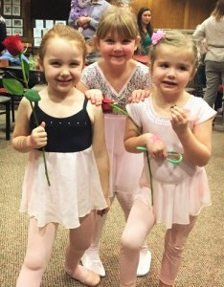**

*Dancin’ with Deja class participants after their winter recital, held at BreakPoint Community Church in Overland Park.*

*Quinn Welch thought about what to ask for, while Santa considered whether Quinn had been naughty or nice.*

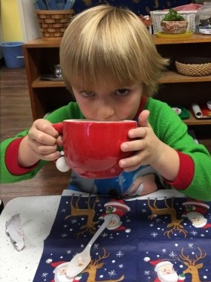**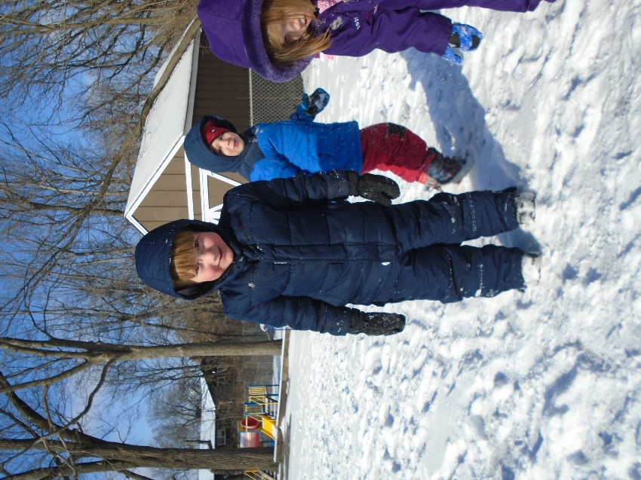**

*Sullivan Jones and Louis Kirchner had fun in the first snow of the season in late December.*

*Henry Merker enjoyed a BIG cup of hot cocoa during the Polar Express Pajama party in classroom 3.*

**Wishing Star Thanks**

We are grateful to everyone who included our teachers, classrooms, and our school as a whole in their holiday gift giving. If you and your child are still interested in extending some holiday cheer, we hope you’ll consider granting one or more of the small wishes that appear on our Wishing Star displays.

**We Appreciate Punctuality**

We start Montessori time in the classrooms earlier in the mornings when the weather turns cold. We appreciate all of the extra efforts parents make to get their children to school on time. The children are better able to focus on their work without distractions that late arrivals can cause. When tardiness can’t be helped, please accompany your child to his or her classroom, say your good-byes quickly and quietly at the classroom door, and let your child’s teacher take it from there.

A friendly reminder about pick-up times: depending on the program your child is enrolled in, a parent or other authorized adult needs to pick him or her up at 11:30 a.m., 12:30 p.m., or no later than our 6:00 p.m. closing time. Please do your best to be here a few minutes before 6:00 to check your child’s cubby box, gather belongings, sign out, etc. Our goal is to have the doors lock up at 6:00 so that our staff members can get home to their own families.

**MCj02321900000%5b1%5dMCj03308380000%5b1%5dMCj03086270000%5b1%5dJanuary & Early February Menu**

|  |  |  |  |  |
| --- | --- | --- | --- | --- |
| Monday | Tuesday | Wednesday | Thursday | Friday |
| 4  Chicken Hot Dog (on wheat bun)  Fresh Vegetable  Fresh Seasonal Fruit  Milk  (+ snacks) | 5  Sunflower Butter & Jelly Sandwich (on wheat)  Fresh Vegetable  Fresh Seasonal Fruit  Milk  (+ snacks) | 6  Pasta with Tomato/Veggie Sauce  Spinach/Garlic Bread  Peas  Apple Slices  Milk  (+ snacks) | 7  Bean Salad  Croutons  Carrots & Cherry Tomatoes  Orange Slices  Milk  (+ snacks) | 8  Breakfast for Lunch:  Oatmeal Bake with Bananas & Peaches  Cereal  Fresh Seasonal Fruit  Milk  (+ snacks) |
| 11  Chili with Quinoa & Vegetables  Corn Bread  Applesauce  Milk  (+ snacks) | 12  Chef’s Salad *(with turkey, eggs, beans & cheese)*  Spinach/Garlic Bread  Carrots  Orange Slices  Milk  (+ snacks) | 13  Turkey & Cheese Sandwich (on wheat)  Fresh Veggies  Fresh Seasonal Fruit  Milk  (+ snacks) | 14  Ham, Egg & Vegetable Casserole  Green Beans  Fresh Seasonal Fruit  Milk  (+ snacks) | 15  Bean & Rice Patties with Veggies  Salsa  Carrots & Cucumbers  Apple Slices  Milk  (+ snacks) |
| 18  Breakfast for Lunch:  Pancakes  Cereal  Fresh Seasonal Fruit  Milk  (+ snacks) | 19  Minestrone Soup  Garlic Bread  Carrots & Corn  Peaches  Milk  (+ snacks) | 20  Green Salad with Ham & Cheese  Croutons  Fresh Veggie Sticks  Apple Slices  Milk  (+ snacks) | 21  Chicken & Rice Soup with Kale  Crackers  Peas  Pears  Milk  (+ snacks) | 22  Bean, Cheese & Veggie Burritos  Carrots & Jicama  Orange Slices  Milk  (+ snacks) |
| 25  Couscous Salad  Spinach/Garlic Bread  Corn  Bananas  Milk  (+ snacks) | 26  Chicken Noodle Soup with Veggies  Crackers  Green Beans  Pears  Milk  (+ snacks) | 27  Roasted Vegetables & Turkey Sausage  Wheat Rolls  Peas  Peaches  Milk  (+ snacks) | 28  Deli Plate  Fresh Veggies  Fresh Seasonal Fruit  Milk  (+ snacks) | 29  Breakfast for Lunch:  Scrambled Eggs with Spinach & Cheese  Cereal  Fruit Salad  Milk  (+ snacks) |
| Feb 1  Pasta with Tomato/Veggie Sauce  Green Beans  Peaches  Milk  (+ snacks) | 2  Toasted Cheese & Spinach Sandwich *(on wheat)*  Carrots & Peppers  Fresh Seasonal Fruit  Milk  (+ snacks) | 3  Lemony Lentil Soup with Veggies  Crackers  Green Beans  Fresh Melon  Milk  (+ snacks) | 4  Bean Salad  Spinach/Garlic Bread  Sweet Potato Wedges  Pears  Milk  (+ snacks) | 5  Potato Soup  Crackers  Peas  Apple Slices  Milk  (+ snacks) |

## Classroom Happenings

**From Deja in Classroom #2:**

We are very excited to be starting a new year. In January, we will be learning about animals that live in Antarctica. We will also talk about Dr. Martin Luther King, Jr. and the way he helped change our country. Our sound-of-the-week work will start again with the letter/sounds c, u, p and r.

February may be a short month, but we have a lot to talk about. We will learn all about Ground Hog Day and celebrate our nation’s presidents. We will celebrate the Chinese New Year on February 8 (2016 is a year of the monkey in the Chinese zodiac). Since it is African-American History month, we will learn about some famous African Americans who helped our country become what it is today. Sounds of the week will be w, l, j and g.

As most of you know, Anna is getting married and moving away in January. Since the day Anna started working here in June of 2012, she has given 110 percent every day, loving every one of your children and treating them with kindness, respect, and a healthy sense of humor. Although our hearts are heavy, we wish Anna and her new husband, Jared, all the best that life has to offer! Anna and Jared Kouba’s new home is at 610 Gentry Street, El Dorado Springs, MO, 64744, if you’d like to keep in touch.

Shawne Pennington (Ms. Angie’s sister) has accepted the position of assistant teacher in classroom 2. She has 9 and 11-year-old sons, one of whom is on the autism spectrum. Shawne was a stay-at-home mom for many years, but recently worked for the Local Investment Commission (LINC) in their before and after-school care programs and as a reading and classroom behavior assistant. She also has experience as a behavioral specialist for the Midwest Foster Care and Adoption Agency shelter. Welcome, Shawne, to our school family!

**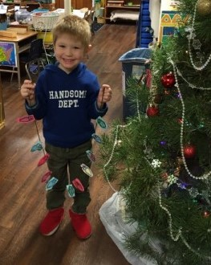From Emilie in Classroom #3:**

Happy New Year!  I hope that everyone had a great holiday season.

Our Thanksgiving feast was great! We learned how the pilgrims and the Wampanoag Indians shared food. The children helped set up our classroom’s Thanksgiving table, prepared fruit, and picked up our lunch from the kitchen. We had a wonderful time. December, one of our favorite months, began with a field trip to D & G Tree Farm. Thanks to all of the parents who braved the chilly morning weather and muddy ground to help us find that special tree, which we trimmed with hand-made decorations. The children performed their annual Christmas play, followed by a celebration and book exchange. They did an awesome job and made me so proud! Coming to school in our pajamas for our annual Polar Express party was a cozy and fun day. What a memorable year!

In January and February, we will continue to study numbers and letters; celebrate 100 days of school, Kansas Day, Groundhog Day, and Valentine’s Day; and learn much more.

*Liam Raithel and his string of lights, ready to hang on the tree in classroom 3.*

**From Tammy in Classroom #4**

Well, we’ve made it to another year! Many thanks to the parents who made our annual December field trip to the Christmas tree farm one to remember. It was cold and very muddy, but that didn’t stop us from finding the perfect tree for our classroom. The children loved keeping track of our “elf on a shelf,” Mr. Jingles. He kept the children intrigued, wondering what he was up to in the middle of the night and where he might show up next. The busy Christmas season didn’t keep us from having a “science” project. We planted “candy cane seeds” in magic sugar dust. The children checked daily to see if candy canes would actually grow. The looks on their faces when they saw that the candy canes were ready to pick were priceless!

Thank you, parents, for giving via our Wishing Star program. The children will enjoy opening new work for our classroom shelves. The personal gifts I received were so thoughtful; you certainly made me feel special! Now it’s back to full school mode.

**From Nancy in Classroom #5**

We hope that everyone had a very merry Christmas and a happy new year celebration. We would also like to thank you for your participation in our Wishing Star program and for your personal gifts. We are looking forward to receiving our new classroom materials and appreciate your continued support and generosity.

In January, we will be celebrating Kansas Day, learning about Antarctica and water versus land, and discussing Martin Luther King and his legacy. Our letter/sounds will be r, w, i and g. In February, our learning themes will include shapes, presidents Washington and Lincoln, and letter/sounds j, l, k and q. We will also celebrate Valentine’s Day.

The children love snow and we go outside to play in it! Please make sure that your child has appropriate seasonal clothing in their storage box, and please label every single item.

bd07842_**Spotlight on Math in the Montessori Classroom**

Once a child has mastered several activities in the classroom’s Practical Life and Sensorial areas, activities in the Math area can be introduced. It is important to master the Practical Life and Sensorial materials first because they help the child develop attention span.

In the Math area, the child first learns to recognize the numerals 1 through 10. Once this is mastered, the child can have lessons in teen numerals, fractions, addition, subtraction and decimal place value. Number rods, spindle boxes and golden beads are among the Montessori tools used to teach these concepts.

**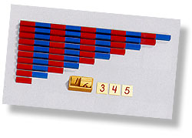Number Rods** (often in red and blue)

Direct Aims:

* Learning sets of 1-10
* Preparing for counting 1-10
* Developing the concept of the linear value of quantity

Indirect Aims:

* Developing a sense of accurateness
* Preparing for an understanding of the sequence of numbers
* Developing concentration

**Spindle Boxes**

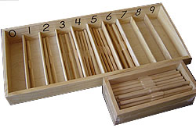

Direct Aims:

* Providing practice in associating quantity and the symbols for 0 to 9
* Developing the idea that each quantity can be made up of loose units taken together as one set
* Learning the numbers in sequence and practicing counting
* Learning the term “set”
* Learning the concept of zero as an empty set

Indirect Aims:

* Developing independence and concentration
* Developing a sense of accurateness

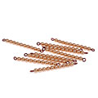

**Golden Beads**

ten bars

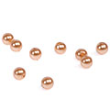Golden Beads are introduced after the child has mastered recognizing the numerals 1-10.

units

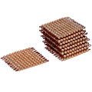First, the child learns that one individual bead is a “unit.” Then, in a 3-period lesson, the child learns that:

thousand cube

* 10 units strung together onto a bar is called a “ten bar.”
* 100 units (or 10 ten bars) is known as a “hundred square.”
* 1,000 units (10 hundred squares), depicted as a cube, is called a “thousand cube.”

hundred squares

Golden beads can then be used to teach decimal place value, addition, subtraction, multiplication and division.

###### Johnson County Montessori Preschool follows

###### jcmslogothese exclusion-from-school recommendations

###### from the Johnson County Health Department

|  |  |  |
| --- | --- | --- |
|  | **Exclude from School When Child Has:** | **Readmit to School When:** |
| **Symptoms suspected of being contagious or infectious** | Fever with or without any other symptoms | Fever-free for 24 hours without the aid of medication. |
| Eyes inflamed with purulent discharge | Drainage has stopped, or treated for 24 hours with antibiotic, or physician sends note stating that child is non-infectious. |
| Drainage from ear | Drainage has stopped. |
| Lice | After treatment with an approved antiparasitic is initiated. |
| Diarrhea (two or more loose or watery stools) | Diarrhea-free for 24 hours without the aid of medication. |
| Vomiting | Free of vomiting for 24 hours. |

|  |  |  |
| --- | --- | --- |
|  | **When Child Has This Skin Affliction:** | **Exclusion / Provision:** |
| **Any open or draining/oozing lesion must be kept covered** | Athlete’s Foot | No exclusion necessary, but must keep shoes and socks on for all activities. |
| Hand, Foot and Mouth | Exclude from school until fever-free for 24 hours without the aid of medication and no open lesions. |
| Herpes | No exclusion necessary, but no participation in activities involving skin-to-skin contact until five days after lesions have crusted. |
| Impetigo | Exclude from school until treated for 24 hours with antibiotic, or physician sends note stating that child is non-infectious. |
| MRSA | If lesions can be covered, then no exclusion necessary. If lesions cannot be covered, exclude from school until lesions have crusted over. |
| Molluscum Contagiousum | No exclusion necessary, but no participation in activities involving skin-to-skin contact or after curettage. |
| Rash | Consider exclusion from school pending a physician evaluation. |
| Ringworm | Exclude from school until after treatment has been initiated. No participation in activities involving skin-to-skin contact until lesions are completely healed. |
| Scabies | Exclude from school until after treatment with an approved antiparasitic is initiated. |
| Shingles | If lesions can be covered, then no exclusion necessary. If lesions cannot be covered, exclude from school until lesions have crusted over. |
| Varicella (Chicken Pox) | Exclude from school until all lesions have formed scabs or are crusted over. |

# Guidelines for Medications

* *Any* medication (prescription or over-the-counter) to be administered to your child at school must be entered on the medication authorization register *each morning*.
* The medication must be in the original bottle/container, and the bottle/container must be clearly labeled with the child’s *full name*.
* Place the labeled, original bottle/container in a plastic zipper bag and give the bag to your child’s teacher.
* Please notify your child’s teacher if medication is to be administered before lunch rather than at lunch.
* All unfinished medication must be taken home.